**RESISTERS IN SERIES AND PARALLEL.**

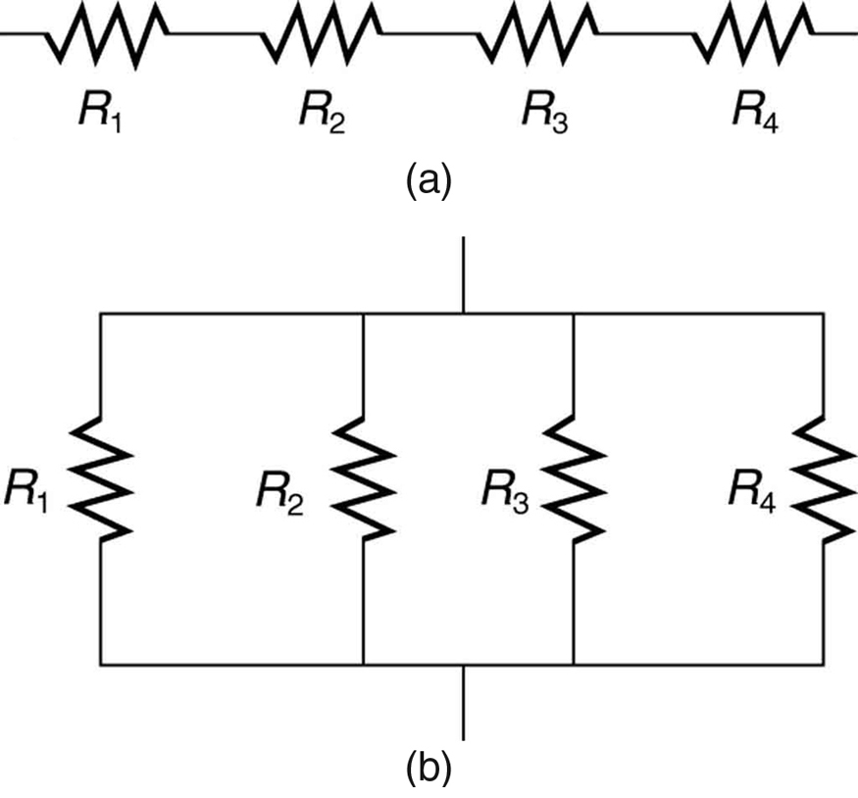

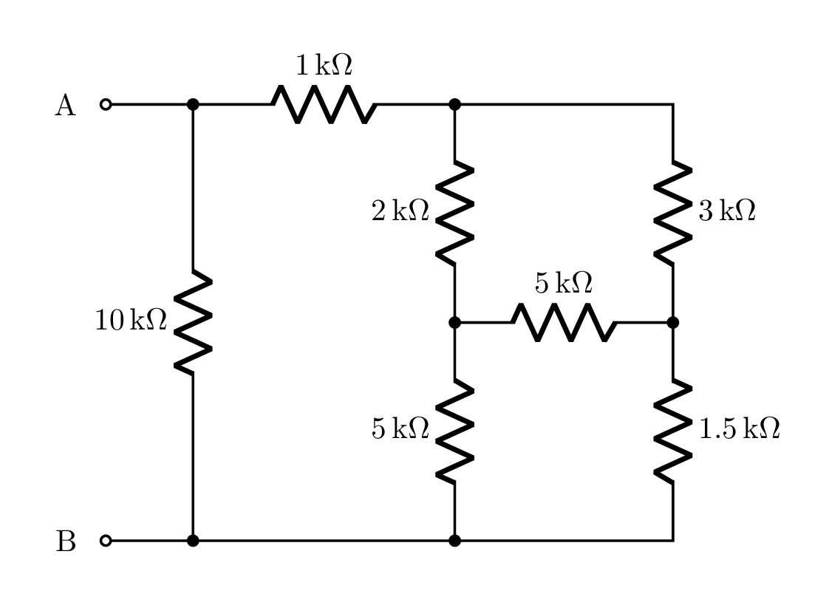**SERIES -PARALLEL COMBINATION OF RESISTERS.**

## What is a Series Circuit?

A circuit is said to be connected in series when the same current flows through all the components in the circuit. In such circuits, the current has only one path. Let us consider the household decorative string lights as an example of a series circuit. This is nothing but a series of multiple tiny bulbs connected in series. If one bulb fuses, all the bulbs in the series do not light up.

## What is a Parallel Circuit?

A circuit is said to be parallel when the electric current has multiple paths to flow through. The components that are a part of the parallel circuits will have a constant voltage across all ends.

## Difference Between Series and Parallel Circuits

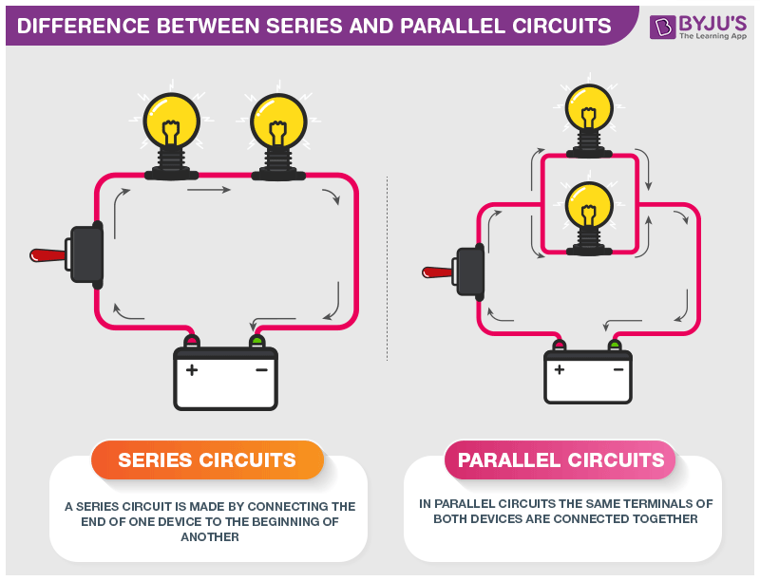

|  |
| --- |
| **Difference Between Series and Parallel Circuits** |

## Resistors in Series

Two or more resistors are said to be connected in series when the same amount of current flows through all the resistors. In such circuits, the voltage across each resistor is different. In a series connection, if any resistor is broken or a fault occurs, then the entire circuit is turned off. The construction of a series circuit is simpler compared to a parallel circuit.

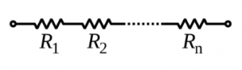

Resistors in series combination

For the above circuit, the total resistance is given as:

Rtotal = R1 + R2 + ….. + Rn

The total resistance of the system is just the total sum of individual resistances.  
For example, consider the following sample problem.

A resistor with an electrical resistance value of 100 ohms is connected to another with a resistance value of 200 ohms. The two resistances are connected in series. What is the total resistance across the system?

Here, R1 = 100 Ω and R2= 200 Ω

Rtotal = 100 + 200 = 300 Ω

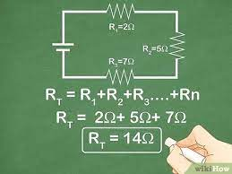

## Resistors in Parallel

Two or more resistors are said to be connected in parallel when the voltage is the same across all the resistors. In such circuits, the current is branched out and recombined when branches meet at a common point. A resistor or any other component can be connected or disconnected easily without affecting other elements in a parallel circuit.

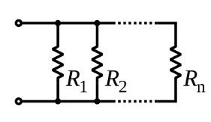

Resistors in parallel combination

